PRACTICALS - SPOTTERS

- IDENTIFICATION
The given picture is identified as wind pollinated flowers

COMMENTS
Characteristics of Wind pollinated flowers
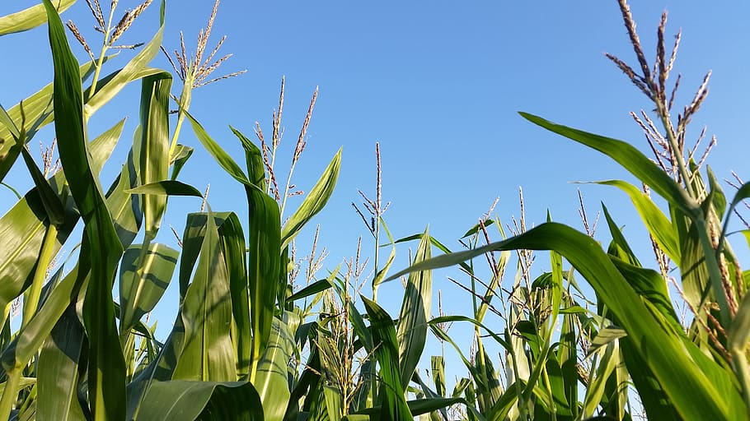

1.Large production of pollen grains.

2. The anther is well exposed.

3. are not attractive and scent emitting.

4.Feathery and sticky stigma.
The pollen grains are light and non-sticky so that they can be transported in wind currents.

5. Flowers do not possess nectar.

2.IDENTIFICATION
The given picture is identified as insect pollinated flowers

COMMENTS

Characteristics of Insect pollinated flowers
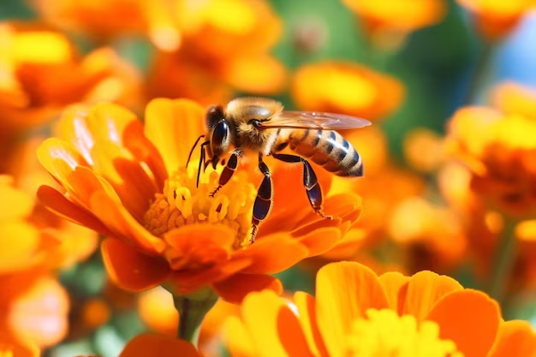

1.Large and coloured petals to attract insects.

2.Nectar to attract insects.

3. Pollen grains are sticky so that they can stick easily to insect's body parts.

CHARACTERISTICS OF WATER POLLINATED FLOWERS
IDENTIFICATION
The given picture is identified as water pollinated flowers

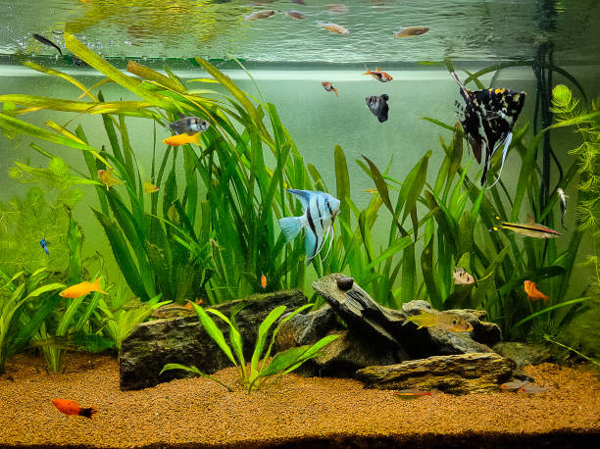
COMMENTS
Flowers are colorless, small, inconspicuous without nectar and fragrance.
- Pollen grains are long, ribbon-like structures which are carried with current of water.
- The pollen grains are light but covered with wax, in order to protect them from wetting.

EMASCULATION

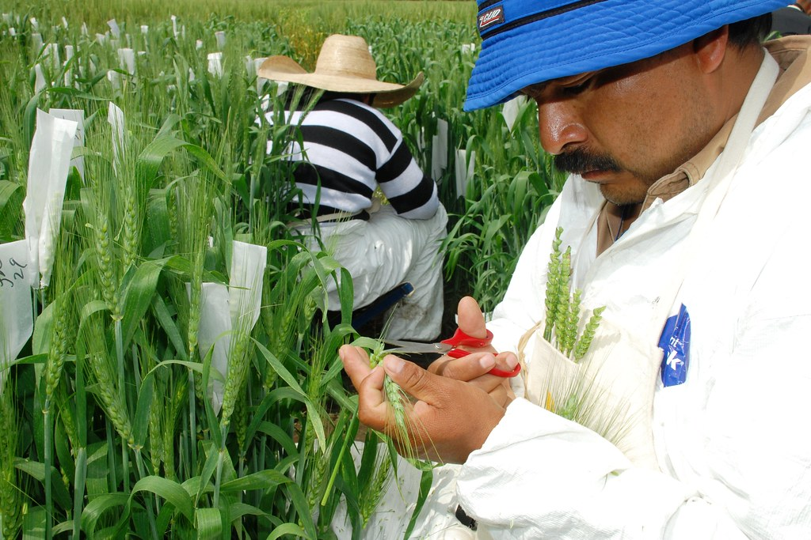
IDENTIFICATION
The given identified picture is identified as Emasculation

NOTES

1.Emasculation is the process of removing anthers from bisexual flowers without affecting the female reproductive part (pistil), which is employed in various plant hybridization techniques.

2.The instrument used in this method include pocket lens ,forceps ,needle , scissors ,scalpel and camel hair brush.

3.This method helps to perform cross pollination which brings about variation in the type of plant. The bisexual flowers can be made to cross with another plant type to produce desired variety.

BAGGING
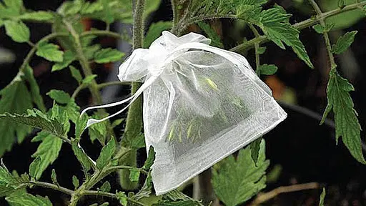

COMMENTS
- After emasculation the flowers are covered with small bags to prevent pollination with undesired pollen grains.
- These bags are made up of polythene ,paper , muslin cloth or parchment paper.
- The bags are punctured or made perforated so as to provide aeration to the flowers.
- The flowers of male parents are also protected in bags to prevent mixing of their pollen grain with foreign pollens.
- A label of paper is tagged on the plant which display the date of emasculation , crossing and brief account of the parents.

